Teleopti Internal:

Used as a master copy for our AWS Quick Start:

<https://aws.amazon.com/quickstart/connect/TeleoptiWFM/>

Changes?

1. update this doc.
2. Send an update to some,email@amazon.com
3. Remember to republish the .pdf if you change it  
   Copy From: <https://teleopti.sharepoint.com/:b:/g/Tech/Ea3gOVKibOJCnYeXRPn6YmcBulP5C1UtQ0lUJq9SBf0Qmw?e=7yaR6h>  
   To: <https://github.com/Teleopti/AWS-Connect-Integration/blob/master/doc/Teleopti%20WFM%20-%20Amazon%20Connect%20Integration%20Requirements.pdf>  
   (GitHub client needed)

To the Quick Start Team at AWS:

**Picture:**

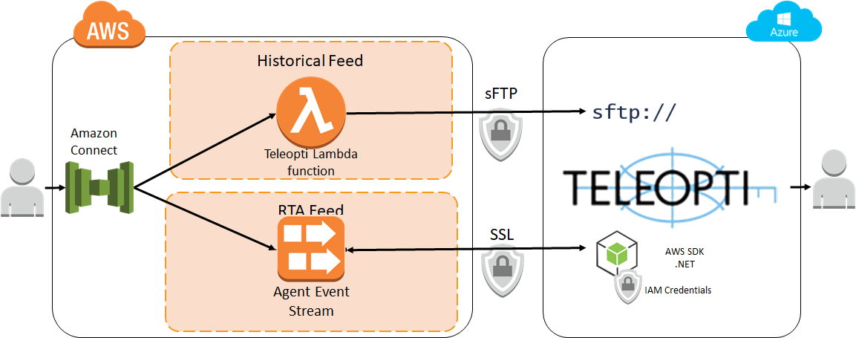

**howTo:**

To add the Teleopti WFM Integration to Amazon Connect:

|  |  |
| --- | --- |
| Step 1 | [Sign up for an AWS account](http://docs.aws.amazon.com/connect/latest/adminguide/gettingstarted.html#sign-up-for-aws), if you don't already have one.  Getting an account will automatically sign you up for Amazon Connect and all other AWS services. |
| Step 2 | Contact Teleopti PS Services to setup a Teleopti Log Server session in the Teleopti Azure Cloud. Teleopti will provide you with:   * sFTP hostname * sFTP credentials   This will be needed in Step 3 |
| Step 3 | [Deploy the integration](https://console.aws.amazon.com/cloudformation/home?region=us-east-1" \l "/stacks/create/review?stackName=Amazon-Connect-TeleoptiWFM&templateURL=https://s3.amazonaws.com/quickstart-reference/connect/integration/aria/latest/templates/TeleoptiWFM.template" \t "_blank).  Launch the AWS CloudFormation template that performs the integration, and complete the parameter fields. Deployment takes just a few minutes. Note: Amazon Connect are currently limited to the US East (N. Virginia) Region. |
| Step 4 | [Configure the integration](https://github.com/Teleopti/AWS-Connect-Integration/blob/master/doc/Teleopti%20WFM%20-%20Amazon%20Connect%20Integration%20Requirements.pdf" \t "_blank).  Follow the steps in the Teleopti WFM Integration documentation to complete configuration tasks. By the end of configuration process You will provide the following into to Teleopti:   * IAM User * Access Key * Secret Access Key |
| Step 5 | Teleopti uses the above credentials to configure the RTA SDK Client listener + Historical data Integration |

note: You are responsible for the cost of the AWS services and partner solutions used while running this Amazon Connect integration.

**Description**:

With Teleopti Workforce Management (WFM) and Amazon Connect you ensure your customer service organization has the right person with the right skills in the right place and at the right time - regardless of the method of contact. Teleopti WFM offers a comprehensive solution that improves agent experience, delivers flexible schedules and ensures customer expectations are met. Benefits include:

• Forecasting - Forecast agents in minutes. Determine interaction volumes and schedule employees to meet demands. Multi-skill, multichannel for both short and long-term planning, as well as for trends and seasonality analyses

• Scheduling & Work-life balance - Powerful, multi-skill, scheduling-optimization (chat, email) engine for effective agent planning, taking into account work-hour legislation, demand, employee requests – and more.

• Real-time Adherence (RTA), Real-time agent status and overviews. Track agent adherence and adjust your schedules effortlessly, with drag-and-drop capabilities to maintain service-level goals throughout the day.